Task Scheduling

Before we used a thread pool, we were concerned with creating, controlling and communication between threads. With a thread pool, we were concerned with the task that we wanted to execute. Using an executor allowed us to focus on our program’s logic instead of writing a lot of thread-related code.

Task schedulers give us the opportunity to execute particular tasks at a fixed point in time in the future (or, more correctly, after a fixed point in time in the future). They also allow us to set up repeated execution of tasks. Once again, they free us from many of the low-level details of thread programming: we create a task, hand it off to a task scheduler, and don’t worry about the rest.

Overview of Task Scheduling

Interestingly, this is not the first time that we have been concerned with when a task is to be executed. Previously, we've just considered the timing as part of the task. We've seen tools that allow threads to wait for specific periods of time. Here is a quick review:

The sleep() method
In our discussion of the Thread class, we examined the concept of a thread waiting for a specific period of time. The purpose was either to allow other threads to accomplish related tasks, to allow external events to happen during the sleeping period, or to repeat a task periodically. The tasks that are listed after the sleep() method are executed at a later time period. In effect, the sleep() method controls when those tasks are executed.

The join() method
Our discussion of this method of the Thread class represents the first time that we examined alternate tasks to be executed at a later time. The goal of this method is to wait for a specific event—a thread termination. However, the expected thread termination event may not arrive, at least not within the desired time period, so the join() method provides a timeout. This allows the method to return—either by the termination of the thread or by the expiration of the timeout—thus allowing the program to execute an alternate task at a specific time and in a particular situation.

The wait() method
The wait() method of the Object class allows a thread to wait for any event. This method also provides the option to return if a specific time period passes. This allows the program to execute a task at a later time if the event occurs or to specify the exact time to execute an alternate task if the event does not occur. This functionality is also emulated with condition
variables using the await() method.

The TimeUnit class
This class is used to define a time period, allowing methods to specify a time period in units other than milliseconds or nanoseconds. This class is used by many of the classes added in J2SE 5.0 to specify a time period for a timeout. This class also provides convenience methods to support certain periodic requests—specifically, it provides alternate implementations of the sleep(), join(), and wait() methods that use a TimeUnit object as their timeout argument.

The DelayQueue class
Our discussion of the DelayQueue class in Chapter 8 is the first time we encounter a class that allows data to be processed at a specific time. When a producer places data in a delay queue, it is not readable by consumers until after a specific period passes. In effect, the task to process the data is to be executed at a later time—a time period that is specified by the data itself.

The join( ) Method

The non-static join() method of class Thread lets one thread "join onto the end" of another thread. If you have a thread B that can't do its work until another thread A has completed its work, then you want thread B to "join" thread A. This means that thread B will not become runnable until A has finished (and entered the dead state).

Thread t = new Thread();
t.start();
t.join();

The preceding code takes the currently running thread (if this were in the main() method, then that would be the main thread) and joins it to the end of the thread referenced by t. This blocks the current thread from becoming runnable until after the thread referenced by t is no longer alive. In other words, the code t.join() means "Join me (the current thread) to the end of t, so that t must finish before I (the current thread) can run again." You can also call one of the overloaded versions of join() that takes a timeout duration, so that you're saying, "wait until thread t is done, but if it takes longer than 5,000 milliseconds, then stop waiting and become runnable anyway." Figure 9-3 shows the effect of the join() method.

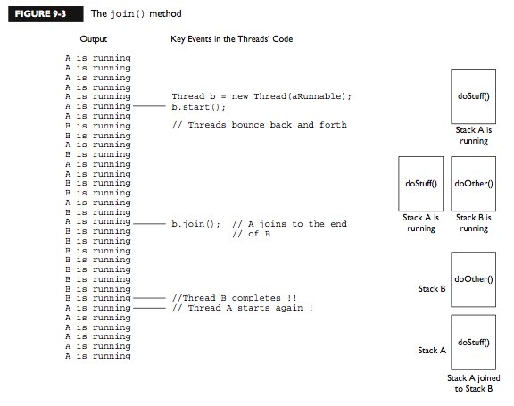

The java.util.Timer Class

The java.util.Timer class was added to JDK 1.3 specifically to provide a convenient way for tasks to be executed asynchronously. This class allows an object to be executed at a later time. The time can be specified either relative to the current time or as an absolute time. This class also supports the repeated execution of the task.

public abstract class TimerTask implements Runnable {
protected TimerTask( );
public abstract void run( );
public boolean cancel( );
public long scheduledExecutionTime( );
}

Tasks to be executed by the Timer class must inherit from the TimerTask class. As in the Thread class, the task to be executed is the run() method. In fact, the TimerTask class actually implements the Runnable interface. The Timer class requires a TimerTask object so that two methods can be attached to the task; these methods can be used to maintain the task. These methods do not have to be implemented; the TimerTask class provides a default implementation for them. A class that inherits from the TimerTask class need only implement the run() method.

The ScheduledThreadPoolExecutor Class

J2SE 5.0 introduced the ScheduledThreadPoolExecutor class, which solves many problems of the Timer class. In many regards, the Timer class can be considered obsolete because of the ScheduledThreadPoolExecutor class. Why is this class needed? Let's examine some of the problems with the Timer class.

First, the Timer class starts only one thread. While it is more efficient than creating a thread per task, it is not an optimal solution. The optimal solution may be to use a number of threads between one thread for all tasks and one thread per task. In effect, the best solution is to place the tasks in a pool of threads. The number of threads in the pool should be assignable during construction to allow the program to determine the optimal number of threads in the pool.

Second, the TimerTask class is not necessary. It is used to attach methods to the task itself, providing the ability to cancel the task and to determine the last scheduled time. This is not necessary: it is possible for the timer itself to maintain this information. It also restricts what can be considered a task. Classes used with the Timer class must extend the TimerTask class; this is not possible if the class already inherits from another class. It is much more flexible to allow any Runnable object to be used as the task to be executed.

Finally, relying upon the run() method is too restrictive for tasks. While it is possible to pass parameters to the task—by using parameters in the constructor of the task—there is no way to get any results or exceptions. The run() method has no return variable, nor can it throw any type of exceptions other than runtime exceptions (and even if it could, the timer thread wouldn't know how to deal with it).

Summary

In this chapter, we've looked at various ways in which tasks may be scheduled in the future. The simplest way to do this is to use the java.util.Timer class, which can run instances of a special class (the TimerTask class) at a point in the future, repeating the task if necessary.

Each instance of a timer is a single thread; that thread can handle multiple tasks but long-running tasks may need their own thread (and consequently their own timer).
The javax.swing.Timer class is functionally similar, except that it ensures that tasks are run on the event-dispatching thread so that they may safely access Swing components.

However, the javax.swing.Timer class has a fixed time schedule for all the tasks it runs; tasks that have different scheduling needs require different instances of the timer.

Finally, the ScheduledThreadPoolExecutor class provides a more flexible (but more complex) interface to task scheduling. Because it uses a thread pool, it can be more efficient when running a lot of tasks simultaneously. It also allows you to poll for task status or to use generic Runnable objects as your task.

The key benefit of task executors and timers is that they free you from having to worry about thread-related programming for your tasks: you simply feed the task to the timer or executor and let it worry about the necessary thread controls. This makes the code that you write that much simpler.

